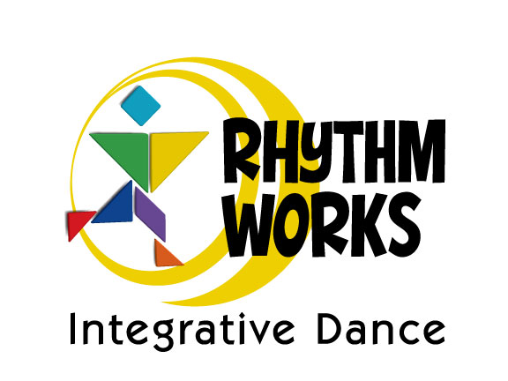STUDENT REGISTRATION FORM

|  |  |  |  |  |  |  |
| --- | --- | --- | --- | --- | --- | --- |
| Student’s Name | | | | Birthdate | | |
| Current Diagnosis if any | Treating Therapist/Teacher that we will work with | | | | | |
| Treating Clinic/School | | | Treating Clinic/School Phone | | | |
| Treating Clinic/School Address | | | | | | |
| City | State | | | Zip | | |
| Guardian 1 Name | | | | Relationship to Student | | |
| Guardian 1 Mailing Address (Street or PO) | | | | | | |
| City | State | | | Zip | | |
| Guardian 1 Cell Phone | Guardian 1 Email Address | | | | | |
| Guardian 2 Name | | | | Relationship to Student | | |
| Guardian 2 Mailing Address (Street or PO) | | | | | | |
| City | State | | | Zip | | |
| Guardian 2 Cell Phone | Guardian 2 Email Address | | | | | |
| Please let us know anything that will help our staff provide the best possible learning experience for your student (sensitivities, developmental goals, behaviors, what helps self-regulation…) | | | | | | |
| Credit Card (Visa/MC only) | | Exp. Date | CVV | | Billing Zip | Amount |
| Name on Credit Card | | Signature | | | | |

**Return to: tricia@rhythmworksid.com or fax to 310-793-2623**



**PRIVACY AGREEMENT**

STUDENT’S NAME ___________________ GUARDIAN’S NAME __________________________

Rhythm Works integrative Dance is a rhythm and dance activity that focuses on developing foundational skills across all 5 developmental domains. In order to be as effective as possible, it is important to work closely with your family and your child’s team of therapists so we may incorporate elements of their developmental goals into our class content. We also work together with our worldwide team of Certified Rhythm Works Integrative Dance Instructors to exchange best practices, methodologies, and student progress so we may all be at our best of all students.

We take the privacy of you and your family seriously. Your agreement to allow us to share information, testimonials, videos, images, etc. will help us to reach other students who can benefit from the RWID program, in addition to training our team of Certified RWID Instructors. It will also help us in data collection to refine the program to be more effective and beneficial for all students. **Please know that we will never use your child’s name in conjunction with any of the following scenarios that you do approve.**

Please indicate your wishes for the scenarios below.

|  |  |  |
| --- | --- | --- |
| I AGREE | I DO NOT AGREE | SCENARIO |
|  |  | Share video/imagery of my child with program Director, Board of Advisors, or researchers, including any diagnosis or therapy goals. |
|  |  | Share video/imagery of my child during instructor training sessions, or via private RWID Certified Instructor portals, including any diagnosis or therapy goals. |
|  |  | Share video/imagery of my child in public forums like the RWID website, Facebook, Twitter, Instagram, or Linked In. |
|  |  | Share verbal (written or recorded) testimonial of my or my child’s experience with Rhythm Works Integrative Dance. |
|  |  | Use video of my child in advertisements to promote classes for students or Certified Instructor trainings. |
|  |  | Use imagery of my child in advertisements to promote classes for students or Certified Instructor trainings. |
|  |  | Please list any other specific scenarios that you wish to allow or disallow that are not listed above: |

Signed:________________________________ Date:____________________________________

Printed name:__________________________ Relation to student:________________________